Topic 3: Exploratory Factor Analysis

1. Introduction
Exploratory Factor Analysis (EFA) is a multivariate interdependence technique used to uncover the underlying latent structure among a large set of observed variables.
Unlike regression or discriminant analysis, EFA does not distinguish between dependent and independent variables. All variables are analysed simultaneously to identify patterns of shared variance.
The primary objective of EFA is to explain correlations among observed variables using a smaller number of unobservable latent factors, thereby achieving model parsimony and reducing multicollinearity.

2. Purpose and Applications of EFA
EFA is used when:
- The researcher does not have a priori knowledge of the number or nature of latent constructs.
- Many observed variables show substantial intercorrelations.
- Data reduction or scale development is required.
Key applications include:
- Identifying latent dimensions underlying survey items
- Reducing variables prior to regression or discriminant analysis
- Constructing composite indices or summated scales
- Diagnosing multicollinearity in subsequent models

3. The Factor Model and Variate
3.1 Factor Model Representation
Each observed variable is expressed as a linear combination of common factors and a unique factor:
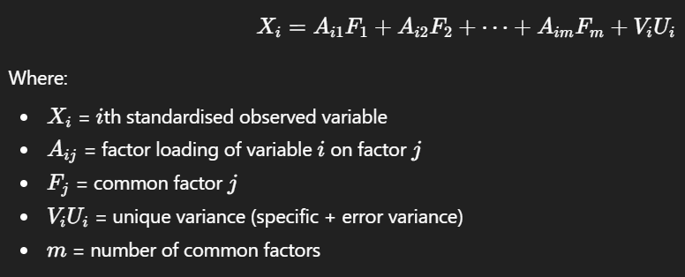

3.2 Factor Scores (Variate Formation)
Common factors can be estimated as linear combinations of observed variables:
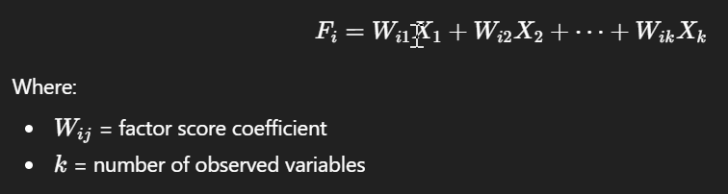
Important:
In EFA, the variate is constructed to maximise explanation of total variance, not to predict an outcome variable.

4. Data Summarisation vs Data Reduction
4.1 Data Summarisation
- Focuses purely on intercorrelations
- Does not require substantive interpretation
- Produces fewer variables for subsequent analysis
- Preferred extraction method: Principal Component Analysis (PCA)
4.2 Data Reduction
- Replaces many observed variables with fewer factors
- Aims for conceptual interpretability
- Supports creation of new composite variables
- Preferred extraction method: Common Factor Analysis (CFA)

5. Sample Size Requirements
Guidelines for EFA reliability:
- Minimum sample size ≥ 100
- Observation to variable ratio ≥ 5:1
Recommended:
  - 10:1 for stable solutions
  - 20:1 for complex models
- High communalities strengthen results

6. Factorability and Measures of Intercorrelation
6.1 Correlation Matrix Inspection
- Substantial correlations > 0.30 required
- Partial correlations should be small
6.2 Kaiser–Meyer–Olkin (KMO) Measure
- Measures sampling adequacy
- Acceptable threshold:
KMO>0.50
KMO increases when:
- Sample size increases
- Average correlations increase
- Number of variables increases
- Number of factors decreases
6.3 Bartlett’s Test of Sphericity
Hypotheses:
- H0H_0H0​: Correlation matrix is an identity matrix
- H1H_1H1​: Correlations exist among variables
Decision rule:
- Reject H0H_0H0​ if p<0.05p < 0.05p<0.05

7. Factor Extraction Methods
7.1 Principal Component Analysis (PCA)
- Extracts maximum total variance
- Includes shared, specific, and error variance
- Best for data reduction
7.2 Common Factor Analysis (CFA)
- Extracts shared variance only
- Focuses on latent constructs
- Best for theory development

8. Communalities and Variance Partitioning
8.1 Communality
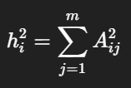
Interpretation:
- Proportion of variance in XiX_iXi​ explained by common factors
- Acceptable rule: hi2​≥0.50
Variables with low communalities should be reconsidered or removed.

9. Determining Number of Factors (Stopping Rules)
- Latent Root Criterion
Retain factors with eigenvalues ≥ 1
- Percentage of Variance Criterion
Retain factors explaining substantial cumulative variance
- Scree Test
Retain factors before the “elbow” of eigenvalue plot
- A Priori Criterion
Based on theoretical justification

10. Factor Rotation
Rotation improves interpretability without changing explained variance.
10.1 Orthogonal Rotation
- Factors remain uncorrelated
- Most common: Varimax
10.2 Oblique Rotation
- Factors allowed to correlate
- Common method: Oblimin

11. Factor Loadings Interpretation
Loading Size | Interpretation
< ±0.10 | Negligible
±0.30 – ±0.49 | Minimum
±0.50 – ±0.69 | Practically significant
≥ ±0.70 | Well-defined structure

12. Cross-Loadings and Re-Specification
12.1 Cross-Loading Ratio
Ratio = Higher loading / Lower loading
Interpretation:
- < 1.5: problematic
- 1.5–1.9: potential issue
- ≥ 2.0: ignorable
12.2 Remedies
- Ignore minor issues
- Delete problematic variables
- Change rotation method
- Adjust number of factors
- Switch PCA ↔ CFA

13. Validation of EFA Results
Validation methods:
- Split-sample validation
- Replication with new dataset
- Confirmatory Factor Analysis (CFA)

14. EFA and Subsequent Multivariate Analysis
EFA supports:
- Variable selection for regression
- Reduction of multicollinearity
- Construction of discriminant profiles
- Creation of summated scales or factor scores

15. Summary Table
Component | Key Rule
Sample size | ≥ 100 and ≥ 5:1 ratio
KMO | > 0.50
Bartlett | p < 0.05
Communality | ≥ 0.50
Eigenvalue | ≥ 1
Loading | ≥ 0.50 preferred
Cross-loading ratio | ≥ 2.0 acceptable

16. Concluding Remarks
Exploratory Factor Analysis is a foundational technique in multivariate data analysis. When applied correctly, it enables researchers to understand structure, simplify complexity, and prepare data for advanced modelling. Proper attention to assumptions, factorability, and validation is essential for producing reliable and interpretable results.

Exam Revision Notes

1. What is Exploratory Factor Analysis
Exploratory Factor Analysis (EFA) is a multivariate interdependence technique used to:
- Identify latent (unobservable) constructs
- Explain correlations among many observed variables
- Reduce a large variable set into a smaller number of factors
- Address multicollinearity and improve model parsimony
Key exam phrase:
EFA explains interrelationships among variables by modelling shared variance using latent factors.

2. Nature of EFA (Very Exam-Relevant)
Feature | EFA
Technique type | Interdependence
DV and IV | No distinction
Objective | Structure discovery
Variate purpose | Explain variance, not predict
Data type | Metric variables
Typical use | Data reduction, scale development

3. Factor Model (Must Know)
Factor representation:
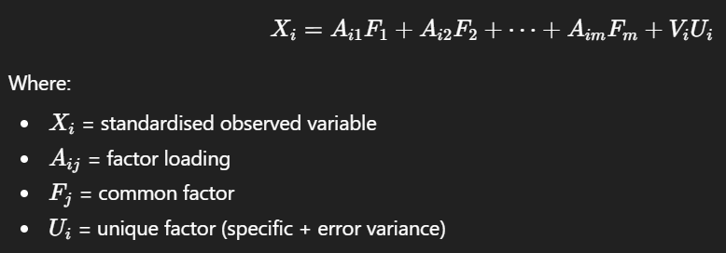Exam tip:
Factors explain shared variance only.

4. Key Terminology (High Yield)
Term | Meaning
Factor loading | Correlation between variable and factor
Communality | Proportion of variance shared with other variables
Eigenvalue | Variance explained by a factor
Unique variance | Variance not shared with others
Factor score | Estimated value of latent factor

5. Sample Size Rules (Frequently Tested)
Minimum guidelines:
- Sample size ≥ 100
- Observation to variable ratio ≥ 5:1
- Preferred: 10:1 or higher
- Higher communalities allow smaller samples

6. Factorability Checks (Always Tested)
(A) Correlation Matrix
- Look for correlations > 0.30
(B) KMO Measure of Sampling Adequacy
KMO Value | Interpretation
< 0.50 | Unacceptable
≥ 0.50 | Minimum acceptable
≥ 0.70 | Good
≥ 0.80 | Very good
Decision rule:
Proceed with EFA only if KMO > 0.50

(C) Bartlett’s Test of Sphericity
Hypotheses:
- H0H_0H0​: Correlation matrix is identity matrix
- H1H_1H1​: Variables are correlated
Decision rule:
- Reject H0H_0H0​ if p < 0.05

7. Extraction Methods (Exam Favourite)
Principal Component Analysis (PCA)
- Uses total variance
- Best for data reduction
- Includes error variance
Common Factor Analysis (CFA)
- Uses shared variance only
- Best for latent construct identification
Exam distinction:
PCA reduces data, CFA explains constructs.

8. Communalities (Must State in Interpretation)
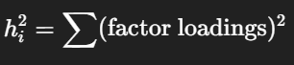
Rule of thumb:
- Communality ≥ 0.50 acceptable
- < 0.50 → variable weakly explained

9. Determining Number of Factors (Stopping Rules)
(A) Latent Root Criterion
- Retain factors with eigenvalue ≥ 1
(B) Scree Test
- Retain factors before the elbow
(C) Percentage of Variance
- Retain factors explaining substantial cumulative variance
(D) A Priori Criterion
- Based on theory

10. Factor Rotation (Interpretation Tool)
Purpose:
- Improve interpretability
- Does not change total variance explained
Orthogonal Rotation
- Factors uncorrelated
- Example: Varimax
Oblique Rotation
- Factors correlated
- Example: Oblimin

11. Factor Loadings (Very High Yield)
Loading Size | Interpretation
< ±0.10 | Negligible
±0.30 | Minimum
±0.50 | Practically significant
≥ ±0.70 | Strong factor structure
Exam phrase:
Loadings ≥ 0.50 are preferred for interpretation.

12. Cross-Loading (Common Exam Trap)
Cross-loading occurs when a variable loads strongly on more than one factor.
Cross-Loading Ratio:
Ratio = Higher loading / Lower loading ​
Ratio | Decision
< 1.5 | Problematic
1.5–1.9 | Potential issue
≥ 2.0 | Acceptable

13. Re-Specification of Factor Model
Triggers:
- Low communality
- No significant loading
- Serious cross-loading
Remedies (least to most extreme):
- Ignore minor issues
- Remove variable
- Change rotation
- Change number of factors
- Switch PCA ↔ CFA

14. Validation of EFA Results
Methods:
- Split-sample validation
- Replication with new data
- Confirmatory Factor Analysis (CFA)

15. Using EFA Results in Other Analyses
EFA helps:
- Reduce multicollinearity in regression
- Select variables for discriminant analysis
- Create summated scales
- Construct factor scores

16. Typical Exam Answer Structure (Recommended)
- State objective of EFA
- Report KMO and Bartlett results
- Identify extraction method
- Justify number of factors retained
- Interpret factor loadings
- Comment on communalities
- Mention rotation method
- Conclude with factor meaning

17. One-Line Exam Summary
Exploratory Factor Analysis identifies latent constructs by modelling shared variance among correlated variables, enabling data reduction and improved interpretability for subsequent multivariate analyses.

Exploratory Factor Analysis (EFA) vs Confirmatory Factor Analysis (CFA) - Final Exam Comparison

1. Core Conceptual Difference (Must State First)
Aspect | EFA | CFA
Purpose | Discover underlying structure | Confirm hypothesised structure
Nature | Data-driven | Theory-driven
Research stage | Early, exploratory | Later, confirmatory
Model specification | No prior structure imposed | Structure specified a priori

High-yield exam sentence:
EFA is used when the factor structure is unknown, whereas CFA is used to test whether a theoretically specified factor structure fits the data.

2. Treatment of Variables
Aspect | EFA | CFA
DV vs IV | No distinction | Explicit measurement model
Variable loading | Variables may load on multiple factors | Loadings fixed according to theory
Cross-loadings | Allowed initially | Typically constrained to zero

3. Statistical Framework
Aspect | EFA | CFA
Technique type | Interdependence | Dependence (SEM framework)
Variance used | PCA: total variance  CFA: shared variance | Shared variance only
Error terms | Implicit | Explicitly modelled
Estimation focus | Factor extraction | Model fit

4. Model Specification (Very Exam-Relevant)
EFA
- Number of factors determined statistically
- Structure emerges from correlations
- Rotation used to aid interpretation
CFA
- Number of factors fixed in advance
- Indicator–factor relationships predefined
- Cross-loadings typically constrained
- Correlated errors explicitly tested
Exam phrasing:
In CFA, the researcher specifies which observed variables load onto which latent factors prior to estimation.

5. Assumptions and Requirements
Aspect | EFA | CFA
Distributional assumptions | Relatively lenient | Stronger assumptions
Sample size | ≥ 100 and ≥ 5:1 | Larger samples preferred
Model identification | Not required | Required
Normality | Less critical | More critical

6. Assessment Criteria
EFA Evaluation Criteria
- KMO > 0.50
- Bartlett’s test p < 0.05
- Eigenvalues ≥ 1
- Scree plot
- Communalities ≥ 0.50
- Factor loadings ≥ 0.50
CFA Evaluation Criteria
- Chi-square goodness of fit
- CFI, TLI, RMSEA
- Standardised loadings
- Construct reliability
- Convergent and discriminant validity
Critical exam distinction:
EFA focuses on factorability and structure discovery, whereas CFA focuses on overall model fit.

7. Rotation vs Model Fit
Aspect | EFA | CFA
Rotation | Required (Varimax, Oblimin) | Not used
Factor correlation | Depends on rotation | Explicitly estimated
Interpretation focus | Loadings and communalities | Fit indices and path coefficients

8. Handling of Cross-Loadings
Aspect | EFA | CFA
Cross-loadings | Diagnosed and resolved | Usually fixed to zero
Model revision | Iterative and exploratory | Modification indices guided
Objective | Achieve simple structure | Improve model fit

9. Validation Role
Aspect | EFA | CFA
Validation purpose | Identify structure | Confirm structure
Typical sequence | First | After EFA
Replication | Recommended | Essential
Exam sentence:
CFA is often used as a validation step following EFA.

10. Use in AA037004 Context
Task | Appropriate Method
Identifying latent dimensions | EFA
Reducing multicollinearity | EFA
Developing measurement scales | EFA → CFA
Testing measurement theory | CFA
Structural equation modelling | CFA

11. One-Line Comparison (Memorise This)
Exploratory Factor Analysis is used to explore unknown factor structures using observed correlations, whereas Confirmatory Factor Analysis tests whether a hypothesised factor structure fits the data within a structural equation modelling framework.

12. Typical Final Exam Question Patterns
You may be asked to:
- Justify the use of EFA instead of CFA
- Explain why CFA cannot replace EFA
- Describe the sequence EFA → CFA
- Compare assumptions, objectives, and outputs
- Identify which method suits a given research scenario

